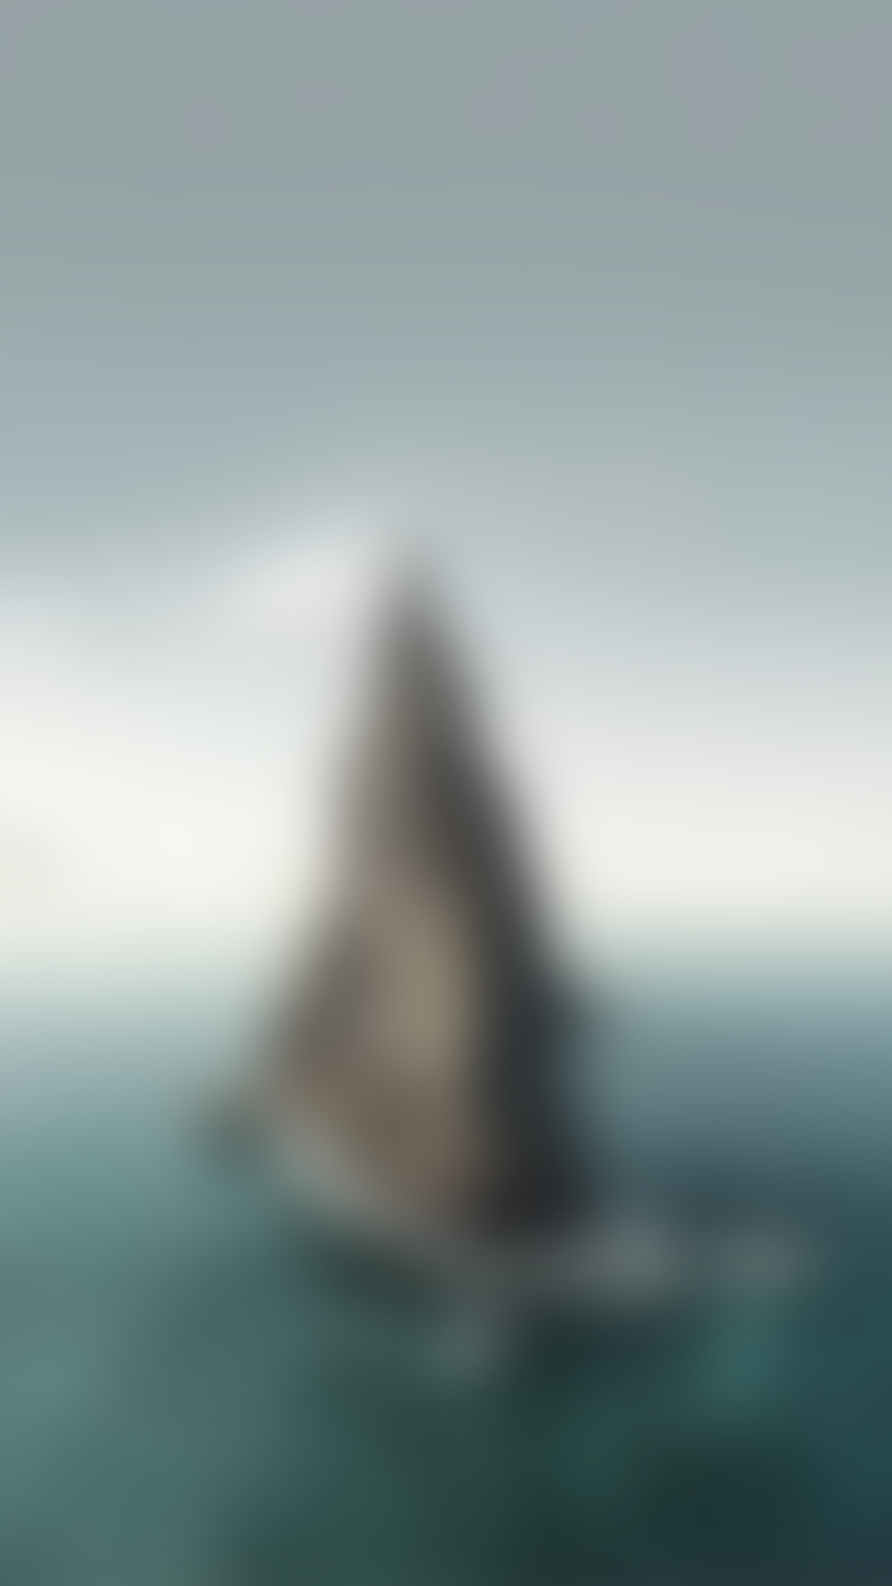

ROCKSTUDIO V2.2 QUICKSTART GUIDE

**Hello and welcome to the quick-start guide for RockStudio V2.2.**

1. **Create a folder called 'Editor Default Resources' and put it directly under the Assets root folder. So this would be Assets/Editor Default Resources.**
2. **Find the folder 'Icons' under Assets/Ameye/RockStudio/Icons and move that folder into the Editor Default Resources folder.**

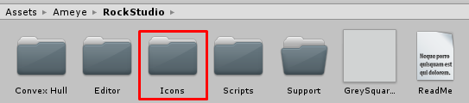

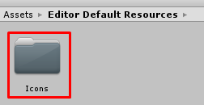

1. **Find the image 'GreySquared.png' under Assets/Ameye/RockStudio and move that file into the Editor Default Resources folder.**

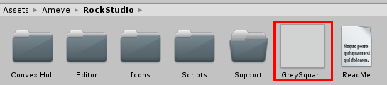

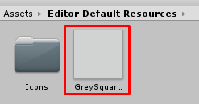

1. **Re-start Unity**
2. **Click Tools/RockStudio**
3. **Enjoy the tool!**